#### Brainstorming

<https://www.kaggle.com/datasets/tr1gg3rtrash/yoga-posture-dataset?select=Adho+Mukha+Svanasana>

If we used this dataset:

* We should convert all the sanskrit pose names to english pose names
  + Adho Mukha Svanasana -> downward dog pose
* We should decide whether to include different variants of same pose:

For example, Downward dog:

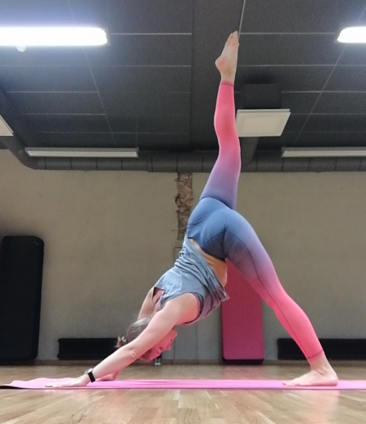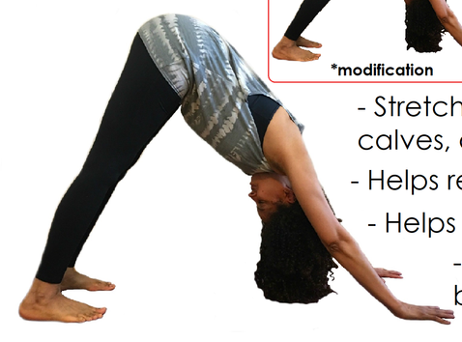

Should we keep both of these variants of pose in training data?

# Research notes on Data Processing/Preparation:

To improve the quality of image data set:

* Make sure that each yoga pose class contains similar amount of image
* To diversify the dataset, we can include image of people of varying level of yoga skills. The model can potentially be used by people with imperfect yoga poses and we still want to be able to classify these. Some categories
  + Beginners practicer
  + Intermediate practicer
  + Advanced practicer
  + Image taken from different angles (let’s say, someone wants to place their phone on the ground while doing yoga. The image taken would be in a low angle view)
* To augment the dataset, we can
  + Rotate the image
  + Flip the image
  + Scale
  + We wouldn’t apply colour transformation (which is another common augmentation technique) because our classifier model only receives a skeleton version of the pose.
* Certain image may contain more than one person. We would have to clean these type of image

To curate a dataset:

* Decide on how many yoga pose we want to classify
* Decide on size of dataset

# Sourcing Yoga Pose Images

* (Chosen)<https://www.kaggle.com/datasets/shrutisaxena/yoga-pose-image-classification-dataset?select=dataset>
  + This dataset contains 107 yoga pose form
  + 5994 images
  + All the names of yoga pose are in Sanskrit. It should be better to leave the names as they are because 1) most of them might not have an English name and 2) we respect the authenticity of yoga traditions
  + I feel like this dataset is the best in terms of number of yoga pose, the diversity (different age groups are represented, for example) and quality of image (there are very few cartoon image, which are present in the next source)
* <https://www.kaggle.com/datasets/tr1gg3rtrash/yoga-posture-dataset/data>
  + 2759 images
* <https://www.kaggle.com/datasets/ujjwalchowdhury/yoga-pose-classification>
  + Downdog
  + Goddess
  + Plank
  + Tree
  + Warrior 2
* <https://www.kaggle.com/datasets/suradechk/yoga-posture-cleaned>
  + Chair
  + Cobra
  + Downdog
  + Goddess
  + Tree
  + Warrior
* <https://www.kaggle.com/datasets/amohankumar/yoga-pose-classification-dataset>
  + This dataset has more yoga poses, but is very chaotic (for example, each yoga pose has many different forms, some images contain many people, some are not even related to yoga)
  + Bridge
  + Child
  + Cobra
  + Downward dog
  + Pigeon
  + Standing mountain
  + Tree
  + Triangle
  + Warrior

# Data Processing

Here are some processing tasks that are required for our chosen dataset (Linked [here](https://www.kaggle.com/datasets/shrutisaxena/yoga-pose-image-classification-dataset?select=dataset))

* Standardize image dimensions. Since images in the dataset are of different dimensions: long rectangles, squares, etc, we would have to standardize all the image dimensions. For example, make them all square, as shown below

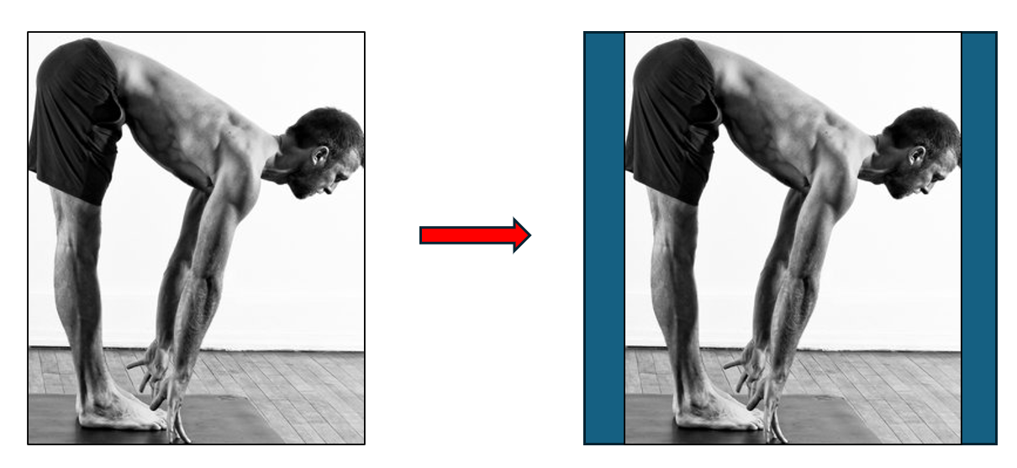

* Remove irrelevant images
* Contains png and jpeg files
* Remove images of more than one person, so that our our training is not unnecessarily computationally heavy
* Currently, for each yoga pose there are around 60 images more or less. I am not sure if this amount is enough to train a good model, but we can always augment our dataset if necessary

**Draft**

The raw dataset created by Shruti Saxena [insert citation] is found on the website kaggle.com. It contains 107 yoga poses, with a total of 5994 images. This dataset is preferable for 3 main reasons: 1) it contains a high number of images, 2) the number of images does not vary significantly across yoga poses 3) it contains diverse representations of people of different gender, age, and ethnicity. With these advantages, we hope to achieve a model that can be used by a larger group of users while having a higher classifying accuracy.

Next, this dataset requires the following steps of data cleaning:

* Standardizing image dimensions will fit all images into a standard-sized square background. This requires downscaling or upscaling images, as shown below.

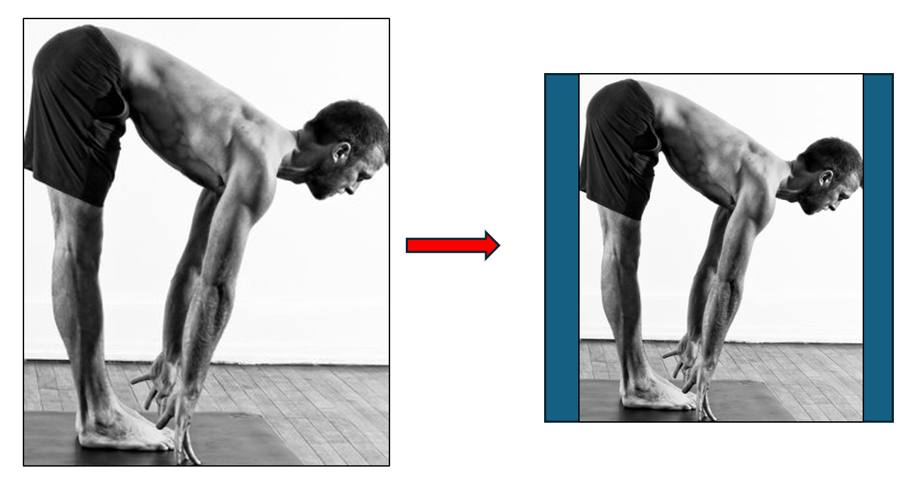

* Although most images are in png format, there are some that is jpeg. Image format conversion is thus required
* Figures in the images will be processed by OpenPose network and become skeletal form. As a result, certain adjustments are required for OpenPose to process the images. For example, we have to adjust the color channel values to within the range of +/- 0.5.
* Images that contain more than one figure will be removed
* At this point, we are unsure whether dataset augmentation is required to train a good model. However, we will augment the dataset if necessary, by rotating, mirroring, scaling, etc.